Data Compilation Process for VRI (phase II), CMI and YSM sample

Prepared by
Forest Analysis and Inventory Branch
Ministry of Forests, Lands, Natural Resources Operations and Rural Development
November 2017

Abstract
This document describes the functions that have been developed to process Vegetation Resources Inventory (VRI) ground sample data.
Generally, described in this document are:
- Methods to derive tree-level attributes (e.g., basal area, whole stem volume and net merchantable volume).
- Methods to derive sample (group)-level attributes (e.g., stand age, stand basal area and stand volume) using tree-level data.
- Methods to calculate ecology and range values.
This document is intended for use by technical persons with an understanding of the VRI process and experience in data manipulation.

Table of Contents
Abstract i
1. Introduction 1
1.1 Background 1
1.2 Purpose 2
2. Derivation of Individual Tree Values 4
2.1 Tree age 8
2.2 Tree basal area 4
2.3 Tree basal area growth rate 10
2.4 Tree per hectare factor (PHF) 4
2.5 Tree volume 5
2.6 Tree volumes for non-enhanced trees Error! Bookmark not defined.
3. Derivation of Tree Group Values 12
3.1 Number of plots 12
3.2 Mean age 12
3.3 Mean tree heights 13
3.4 Site index 14
3.5 Quadratic mean diameter (QMD) 14
3.6 Stems per hectare 14
3.7 Basal area per hectare 15
3.8 Tree volume per hectare 15
3.9 Volume by log grade 16
3.10 Timber value 16
3.11 Damage agents 17
3.12 Proportion of dead trees 17
3.13 Mean annual increment (MAI) 17
3.14 Species composition 17
3.15 Mean bark thickness by species 18
3.16 Small tree summary 18
3.17 Stump volumes 18
4. Coarse Woody Debris (CWD) 20
4.1 Scattered CWD 20
4.2 Accumulated CWD 20
4.3 Totals and classes 21
5. Ecology & Range Derivations 22
5.1 Forage compilation 22
5.2 Range summary data from the vegetation plot 24
5.2 Ecological Summary data: 24
Glossary 25

1. Introduction

1.1 Background

1.1.1 Vegetation Resources Inventory (VRI)
The Vegetation Resources Inventory (VRI) is designed to answer two questions:
- Where is the resource located?
- How much of a given vegetation resource (for example, timber or coarse woody debris) is within an inventory unit?
The VRI is carried out in two phases:
- Photo Interpretation - estimating vegetation polygon characteristics from existing information, aerial photography, or other sources. No sampling is done in the photo interpretation phase.
- Ground Sampling - provides the information necessary to determine how much of a given characteristic is within the inventory area.
The ground measurements resulting from the ground sampling process are used to estimate the proper totals for the population. The relationship between the polygon estimates and ground samples is then used to adjust the photo-interpreted polygon estimates.
The sample data compilation process is performed after ground sampling data measurements have been made and involves using the ground data to derive sample data that cannot be measured directly.

1.1.2 Changing monitoring inventory (CMI)

1.1.3 Young stand monitoring inventory (YSM)
The Forest Analysis and Inventory Branch of the British Columbia Ministry of Forests, Lands and Natural Resource Operations is implementing a monitoring initiative to observe the performance of young forest stands, especially in high-risk forest management units, such as timber supply areas and tree farm licences.1 This program will address the significant information lag between the free-growing declaration for regenerated stands and the point at which these stands are re-inventoried many years later. The key objective of the Young Stand Monitoring Program is: To check the accuracy of the growth and yield predictions (assumptions) of key timber attributes of young stands, which are used in the Timber Supply Review of a management unit, based on an independent random sample of permanent sample plots. Two of the Ministry’s stated goals are “maximum productivity of forest and range resources” and “well-managed forest and range resources.” To achieve these goals, accurate, defensible information on the actual growth of British Columbia’s young stands is required. This information note provides an overview of sample design, analysis, and application of the monitoring data, as well as some empirical evidence from Tree Farm Licence No. 52.

1.2 Purpose and roadmaps
This document describes the procedures that have been developed to process VRI phase II, CMI and YSM ground sample data. Based on objectives of sample components, the compilation process is divided into:
- DBH tree compilation;
- Site age tree compilation;
- Stump/small tree compilation;
- Coarse woody debris compilation;
- Ecology and range compilation.

. These procedures consist of tree-level attribute calculation and sample (group)-level attribute derivation.
1. Methods to derive tree values:
- Age adjustments
- Projected heights for broken top trees
- Per hectare factor
- Basal area
- Basal area increment
- Volume
2. Methods to derive sample (group) values:
- Number of plots
- Mean age
- Mean height
- Site index
- Quadratic mean diameter
- Basal area per hectare
- Tree volume
- Volume per hectare
- Species composition
- Proportion of dead trees
- Small tree summary
3. Methods to calculate volumes of coarse woody debris and stumps.
4. Methods to calculate ecology and range values:
- Total herbaceous production
- Range summary data
This document does not discuss the results data management processes, the preparation and editing of raw data and the process for compiling the data. The task of editing input data is outside the scope of the compilation process.

2. DBH tree compilation
The basic inputs for the data compilation process are tree measurements. The majority of tree measurement data are collected at the ground sampling stage of the VRI. Those values that cannot be measured in the field, but are required for sample statistics, must be computed. These values include tree volume, age and basal area.

2.1 Tree-level attributes

2.1.1 Tree basal area
The basal area (BA) for a tree is calculated by the area formula for a circle, using the diameter at breast height (DBH, in cm) as input. Basal area is expressed in square meters.
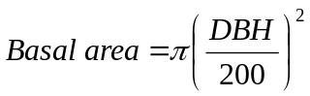 equation (1)

2.1.2 Tree per hectare factor (PHF)
Tree per hectare factor (PHF) is the multiplier used to derive per hectare statistics from sample data. It is more efficient to calculate PHF for each sample tree as a first step as it allows the subsequent statistical computations to be independent of the sampling method (variable radius or fixed area). Also, documentation of statistical algorithms is made simpler. The PHF is calculated using one of two methods, depending on the sampling method:
- For fixed area plots, PHF is the inverse of the plot area. The value is the same for every tree in the plot.
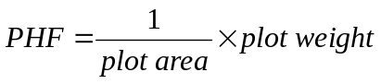 equation (2)
- For trees measured in a variable radius plot, the factor is based on tree basal area and relascope characteristics (Basal Area Factor (BAF)). The PHF varies among trees in a variable radius plot.
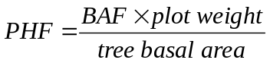 equation (3)
where in both equations, plot weight determines whether the plot is measured as full (valued as 1), half (valued as 2) and quarter swept (valued as 4) plot.

2.1.3 Total tree height for broken top trees
For the fully measured trees, enhanced trees and H-enhanced trees (since 2017), a special procedure is required to derive total tree height for broken top trees to calculate tree volumes. The process of projection total tree height for broken top trees depends on the data availabilities as follows:
- In case of projected total tree heights are provided in the field, these values are used as total tree heights.
- In case of projected total tree heights in the field are not available, total tree heights must be derived using DBH, height and diameter at the break. Specifically, the derivation process consists of multiple iterations as follows:
- Calculate the maximum height increment as maximum allowable tree height (66.6 m) minus break height. The maximum allowable tree height is set as 66.6 m to consistent with the population limit in which Kozak’s equations were derived. Set initial height increment as half maximum height increment and guess the initial total tree height as break height plus initial height increment;
- Use Kozak’s equations to compute an inside-bark diameter at the break height for given guess of total tree height. Calculate the difference between the computed and field-estimated broken top diameter;
- Stop when the absolute difference is less than 0.01 cm;
- Change height increment as half of the current height increment, set guessed total tree height as current total tree height + height increment (if difference is minus) or current tree height – height increment (if difference is positive), repeat 2 and 3 using new guessed total tree height;
- Stop when the height increment is less than 0.1 m.
Projected heights are used only for the purpose of volume derivation. They are not used in calculating mean height or site index.

2.1.4 Tree volume before net factoring
Tree-level whole stem volume (WSV_VOL) and merchantable volume (MER_VOL) are calculated for each full-measured tree, enhanced tree and H-enhanced trees using Kozak’s taper functions (currently version 5.0) and input field data. Kozak functions are available for 16 tree species by Biogeoclimatic zone (BEC). BEC-based volumes are the current standard. A species without a unique equation is assigned to an appropriate function. There are adjustment factors for 3 areas of the province, which further adjust the calculated volumes.
The algorithm adds volumes of 10 cm slices (truncated conic sections) of the height/diameter shape produced by the Kozak function from the bottom of a tree. This method is used so that volumes of logs of varying lengths can be calculated. The inputs for calculating WSV_VOL and MER_VOL are:
- Tree DBH
- Total tree height (including estimate for broken top trees)
- Tree species (input code converted to Growth and Yield (G&Y) old standard set (16 species)
- BEC zone, subzone and variant (current standard)
- Minimum diameter for merchantable volume (10 cm in current standard)
- Stump height (0.3 m in current standard)
- No minimum log length
For non-broken top trees, the WSV_VOL is defined as the all volume from bottom to top of a tree, while MER_VOL is defined the volume between stump height and height at minimum merchantable diameter (Figure 1).

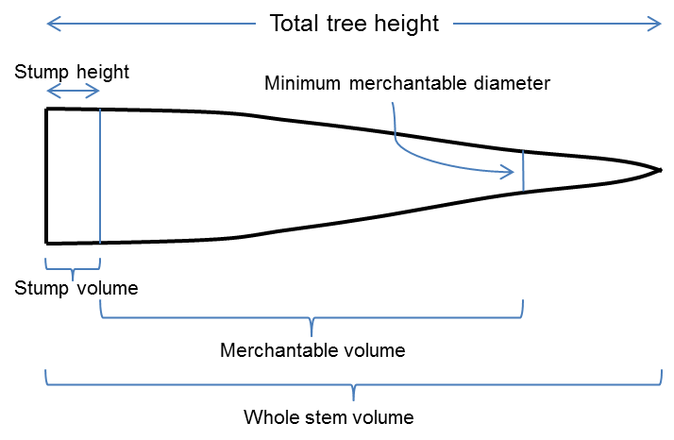
Figure 1. Definition of whole stem volume and merchantable volume for a non-broken top tree.
For the broken top trees, the break heights also are needed to calculate the volumes below and above break point (Figure 2). For these trees, WSV_VOL is calculated as volume below tree break point plus stump volume (Figure 2). The calculation of MER_VOL depends on whether the break height is below or above the height at minimum merchantable diameter. Specifically, when break height is above or same as height of minimum merchantable diameter, MER_VOL is defined as volume between stump height and height of merchantable diameter (Figure 2a). When break height is lower than height of minimum merchantable diameter, MER_VOL is estimated as volume below break point (Figure 2b).
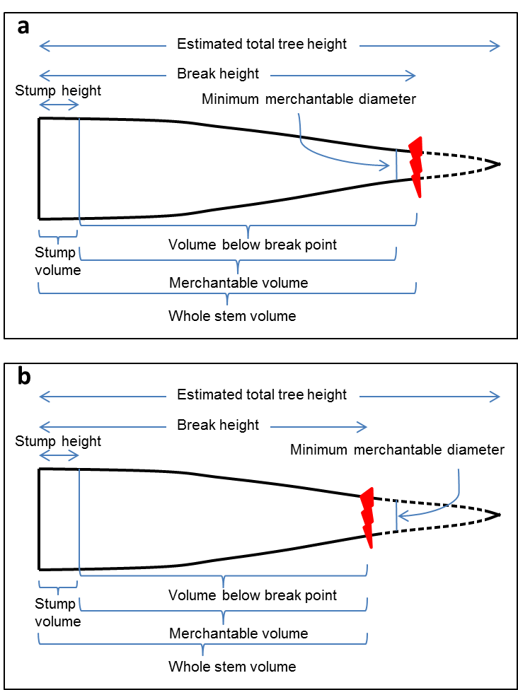
Figure 2. Volume components for a broken top tree.
For the fully-measured trees and enhanced trees, net factoring and call grading information have been collected on a log basis to calibrate net volumes. Therefore, for these trees, volume and merchantable volume are needed to be calculated for each log (Figure 3). Before calculation, log length has to be adjusted against total tree height, i.e., sum of all log length plus stump height must equal to total tree height (Figure 3).
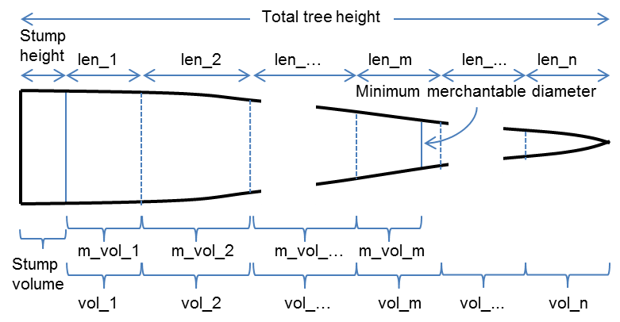
Figure 3. Illustration of log length, volume and merchantable volume for a fully-measured or an enhanced tree. In this figure, len_1, len_2 to len_n are log length for log 1, log 2 and log n, respectively; m_vol_1, m_vol_2 and m_vol_m are merchantable volume for log 1, log 2 and log m, respectively; vol_1, vol_2 and vol_n are volume for log 1, log 2 and log n, respectively. Note that minimum merchantable diameter is in m^{th} log.
For non-enhanced trees, since the tree heights are not available, whole stem volume can not be derived directly using Kozak’s equations. Therefore, a regression method has been used to express whole stem volume as a function of basal area (equation (4)).
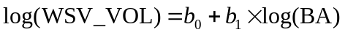 equation (4)
where WSV_VOL and BA are whole stem volume and basal area, respectively. b₀ and b₂ are coefficients to be estimated.
Regressions are conducted for live and dead trees separately within each of 16 species groupings within a project grouping. Project grouping is defined as all projects located in the same geographic area (e.g. a TSA). Multiple projects within a geographic area might exist for reasons such as keeping track of a particular sampling emphasis or to indicate different sampling years. Regression equations are also fit for live and dead trees separately within a deciduous and a coniferous category. Similarly, another set of equations are fit for the two broadest groupings of live and dead trees. These more general equations are used if there are insufficient trees in a species grouping to provide a good regression fit. Insufficiency is defined as less than 3 trees in a group, or an r_square statistic of less than 0.3. For example, if a project grouping contained only 2 dead measured douglas-fir, then this tree would have to use the regression equation for dead conifers.
Once the set of equations are calculated, they are applied to all non-enhanced trees (live and dead) by species group in the project grouping. Whole stem volume for non-enhanced trees is computed as:
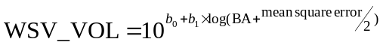 equation (5)
where WSV_VOL, BA, b₀ and b₁ are same as those defined in equation 4; mean square error is specific to the regression model for a given dataset.
The estimate of merchantable volume for non-enhanced trees is achieved using a ratio method as described in next section.
Other outputs include the volume of broken top portion, the volume and top diameter of the stump, diameters at log tops, log volumes and the height at which merchantable diameter limit (10 cm) occurs.

2.1.5 Tree volume after net factoring
For fully-measured trees and enhanced trees, net factoring information has been collected in the field based on each log.
Field estimated percent sound (net factor), grade and length of each log
Pathology indicators
- (4) less calculated waste (W2), and breakage as per BEC based loss factors

For H-enhanced trees and non-enhanced trees,
At one time, a ratio of volume/basal area (vbar) was used to estimate the volume of the non-enhanced trees. The current method involves regression analysis and ratio adjustment.

A ratio is computed for each of the netted volumes as described in Section 2.5.

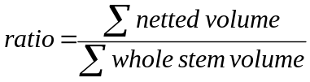

Similar to the regression equations, ratios are computed by project grouping for: live and dead; live and dead within deciduous and coniferous; and live and dead within each of 16 species groupings. Only trees with a DBH >= 10 cm are used in the computation of ratios. As with the regression equations, if there are 2 or fewer trees available for a ratio, the next most generalized ratio must be used (e.g. if there are only 2 dead douglas-firs, these trees would use the ratio for dead conifers).

These ratios are applied to the whole stem volume for each tree, thereby computing all required netted volumes.

2.2 Sample-level attributes

2.2.1 Number of plots
The number of plots in a sample cluster is used in the final averaging that produces per hectare statistics. This count is the total number of plots in a sample and includes plots devoid of trees.
The number of plots is not used in the calculation of dead tree per hectare values as dead trees are only recorded on the integrated plot except for :
- NVAF plots where dead trees may be recorded on auxiliary plots., and
- Samples collected in 2007 and on, when the samples standards changed ot include measurement of dead trees on auxiliary plots,

2.2.2 Quadratic mean diameter (QMD)
The quadratic mean diameter (QMD) is the diameter (dbh) of the tree of average basal area within a group. This can be calculated from tree per hectare factor (Section 2.4) as follows:
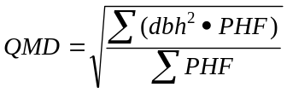
All trees within a sample that have a dbh measurement are included in the calculation. QMD is derived for:
- All live trees by species.
- All live trees within the sample.
- All dead trees within the sample.

2.2.3 Stems per hectare
Stems per hectare is the total estimated number of trees per hectare for:
- Live trees by species.
- All live trees.
- All dead trees.
All in-plot trees with measured dbh are included in the calculation.
Stems per hectare is calculated at five standard utilization levels (dbh limits):
- All trees
- 7.5+ cm
- 12.5+ cm
- 17.5+ cm
- 22.5+ cm
The calculation for stems/ha is:
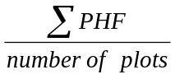

2.2.4 Basal area per hectare
Basal area per hectare is calculated as:
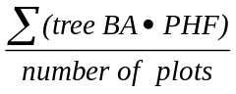
This value is computed at five utilization levels for the following groups of trees:
- Live trees by species within the sample.
- Total live trees within the sample.
- All dead trees within the sample (recorded on the integrated plot only except for NVAF plots)
Basal area/ha is calculated for the following utilization levels (dbh limits):
- All tallied trees
- 7.5+ cm
- 12.5+ cm
- 17.5+ cm
- 22.5+ cm

2.2.5 Tree volume per hectare
Volume per hectare is derived by summing the individual volumes times the per hectare factor for each unique tree . The total volume per hectare is the sum of individual species values. Separate estimates are computed for living and dead trees.
Equation: 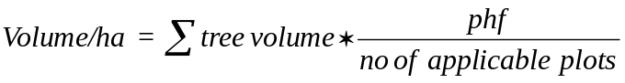
Where applicable plots varies if the volume is for live trees (all plots included), or dead trees (1 if not an NVAF plot).
For each tree species and the total, the following values are derived:
- Whole stem volume/ha.
- Volume/ha less top and stump (current standards: top - < 10 cm diameter, stump - 0.3 m high).
- Volume/ha less decay only (from field data).
- Volume/ha less top, stump and decay (from field data).
- Volume/ha less top, stump and decay, waste (from field data) and breakage from loss factor table.
- Volume/ha less top, stump and decay, waste (from field data) and breakage from loss factor table, adjusted by the net volume adjustment factor (NVAF).
The above values are calculated for the following utilization levels (dbh limits):
- All tallied trees
- 7.5+ cm
- 12.5+ cm
- 17.5+ cm
- 22.5+ cm

2.2.6 Volume by log grade
The VRI call grading procedure assigns a Ministry of Forests (MOF) statutory grade to each log of a sampled ‘volume’ tree. Recorded also for each log are the estimated length and percent sound wood. The VRI compiler uses these inputs and the calculated net log volume to compute the percentage volume per hectare by species and log grade.
The procedure includes the following steps:
- For each species, compute percent net log volume by grade.
- For each species, apply the results of (1) to the species total net volume per hectare.
- Divide the results of (2) by the sample total net volume per hectare and express as a percentage.

3.3 Mean tree heights
The compilation program calculates various mean height values:
Lorry Height – the average stand height weighted by tree basal area, not grouped by species code. Two values are derived: one for all living trees, the other for only live, intact trees (living broken top trees excluded).
Site height - the average height of the selected site trees in the sample. Heights are collected for site trees and one randomly selected tree.
Mean heights are calculated for the following groups if the tree is “suitable” as indicated on the field cards starting in 1999:
- All ‘T’ and ‘S’ (pre-1999) or ‘T’, ‘L’ and ‘S’ (1999) by species.
- The above groups, but including any ‘X’ and ‘O’ site trees.
- The above groups by sample – all species combined.
Two methods are used to derive site height:
1. An average height is calculated for each of the above groups.
2. Site index is used as follows:
- Site index is calculated for each tree using SITE TOOLS.
- A mean site index is derived for each group:
- Using SITE TOOLS, the mean height is derived for each group from the mean site index and mean age (by species only).

3.14 Species composition
Species composition is a ranking of species by percentage of basal area per hectare (standard) or volume per hectare. All live trees tallied in the sample are included in the calculation. The attribute value is a table consisting of genus/species codes occurring in the field data and percentage composition values.
The percent by basal area for a species is calculated as follows:
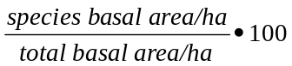
By volume this value is calculated as:
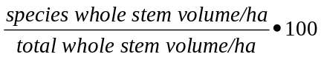

2.2.7 Timber value
Timber value is calculated for a species and log grade and expressed as dollars per hectare. Value is derived by multiplying the net volume/ha by species and log grade by the log market value ($/m³) which is determined by species and log grade. The total dollar value/ha is the sum of the species/log grade values. The dollar values are supplied in a table created in 1999. It is not intended to be a reflection of market price, but an indicator of relative values.

2.2.8 Damage agents
Damage agents are collected and stored for reporting purposes.

2.2.9 Proportion of dead trees
Dead trees are recorded only on the integrated plot (except for NVAF samples or samples measured in 2007 and later). Therefore, only the relevant plot data is used in this calculation (primarily the integrated plot data). The proportion of dead trees is computed from basal area.
The procedure is as follows:
- Compute total basal area of all live and dead trees on the relevant plots.
- Compute total basal area of dead trees.
- Calculate: 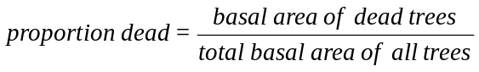

3. Site age tree compilation

2.1.1 Tree age
Tree age is measured on all site trees (first and second leading species as determined by the field crew), one randomly selected tree and one top height (‘T’) tree.
For trees of sufficient size, age is measured by taking ring counts from increment cores usually taken at breast height (1.3 metres).
For trees that are too small to measure by increment cores, there are two methods to determine age:
- Whorl counts, or
- A suitable out-of-plot tree is cut down and the rings on the stump are counted.

Correction for ages not taken at 1.3 m
Tree age, determined by counting the rings at 1.3 metres (m) above the germination point, is required for calculating mean age, site index and total age. The breast height age must be calculated where it is not possible to measure age at 1.3 m. The boring height, the height at which the actual ring count was taken, is used to adjust the boring age to estimate the breast height age.
The adjustment procedure uses the breast height to total age relationship (‘correction’) derived from the SITE TOOLS site index program. The correction is calculated by prorating the SITE TOOLS value by the boring height to breast height ratio.
The adjustment function is:
Breast height age = 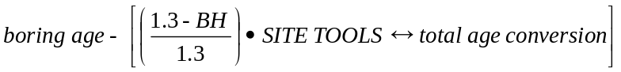
where BH = boring height
The calculation is done iteratively as the SITE TOOLS program requires site index as well as species and age to generate the correction and the SITE TOOLS program must be used to derive the site index.
The following example illustrates the adjustment method.
Inputs:
Species | Coastal Douglas-fir
Boring height (BH) | 0.9 m
Boring age | 91 years
Total tree height | 32 m
Initial iteration:
SITE TOOLS site index 23.7 m (@50 years BH)
BH ↔ total age | 9.4 years
BH Age (est.) = | 91 - ((1.3 – 0.9)/1.3) • 9.4 = 87.2
Second iteration:
SITE TOOLS site index 23.5 m (@ 50 years BH) - using BHA estimate from iteration 1
BH ↔ total age | 9.3 years
BH Age (est.) = | 91 - ((1.3 - 0.9)/1.3) • 9.3 = 87.3

No further iterations are required as the BH age for both iterations round to the same year.

Trees with incomplete ring counts
In cases where it is not possible to count all the rings to the tree centre, the missing ring count must be computed in order to determine the total ring count at boring height.
The estimation method is based on the assumption that average basal area growth is reasonably constant over time. The adjustment procedure extrapolates the average basal area growth rate calculated from the existing ring count to the missing part of the core.
The calculation includes the following steps:
- Calculate the total basal area from the diameter measured inside the bark (ib).
- Calculate the basal area from the length of the intact core.
- Calculate the inverse of the basal area annual growth rate from 2 and the existing ring count (years/cm²).
- Calculate the total boring height age from 1 and 3.
The following example illustrates the procedure.
Inputs:
- Total inside bark basal area
Diameter (outside bark) at boring height | 60.0 cm
Single Bark thickness at boring height | 5.0 cm
Diameter (inside bark) | 50.0 cm
Total basal area (inside bark) | 1,963.5 cm²
- Basal area from intact core
Length of intact core | 15.0 cm
Length of missing core | 10.0 cm
Missing basal area | 314.2 cm²
Intact basal area | 1,649.3 cm²
- Years/cm2 basal area growth from intact core
Ring count of intact core | 60
Years/cm² | .0364
- Total boring height age (1) • (3) = 71.5 years

Total age
Tree total age is derived in the SITE TOOLS program during compilation.
Input values are tree species, site index, breast height age (adjusted as described above, if necessary) and Coast / Interior indicator.

2.3 Tree basal area growth rate
Annual basal area growth rates are calculated at intervals of 5, 10 and 20 years previous to sampling. The input data used are the measured lengths taken from increment cores at the three time intervals, the dbh and bark thickness.
Growth rate is calculated based on the compound increment function:
Current BA = Previous BA (1 + growth rate)^{time}
Therefore: 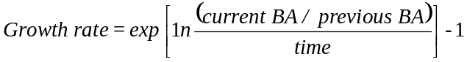
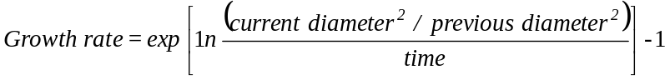
Where: current diameter = dbh - (2 • bark thickness)
previous diameter = current diameter - diameter growth over 5, 10, 20 years
time = 5, 10 or 20 years

4. Derivation of Tree Group Values
Tree group statistics are values calculated for a sample or for a selected group of trees within a sample.
The input data used may be:
- Raw (field) data.
- Tree derived data discussed in the previous section.
- Values from supporting tables.
The VRI compilation program calculates and reports on statistics at the cluster (sample) level. Statistics are often broken down into sub-levels (such as species) where appropriate.

3.2 Mean age
Ages are collected for site trees and one randomly selected tree. Site trees are identified as ‘L’ (leading species in the sample) and ‘S’ (second species in the sample). Out-of-plot (‘O’) and extra (‘X’) site trees may be sampled. Also, the largest diameter tree in the integrated plot is measured and designated as ‘T’. Before 1999, site trees were designated as ‘T’ (primary) or ‘S’ (secondary). From 1999, site trees are designated as suitable or not suitable for use as age trees. If a tree is “not suitable”, then it is excluded from the following calculations.
Mean total age and breast height age are calculated for the following groups:
- All ‘T’ and ‘S’ (pre-1999) or ‘T’, ‘L’ and ‘S’ (1999) by species.
- The above groups, but including any ‘X’ and ‘O’ site trees.
- The above groups by sample – all species combined.
Data sources for age measurements may include:
- Total age reported in the field data.
- Breast height age reported in the field data.
- Derived tree age.
Whatever the source of data, either breast height age or total age is calculated using SITE TOOLS so that both are available for averaging.
For each group of trees described above, both breast height age and total age means are calculated as:
Mean age = 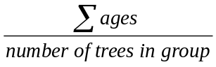
Only one random tree and one top height tree are measured in a given sample. Ages for these trees are carried over and stored in the final results database.

3.4 Site index
Site index is a measure of site quality expressed as the site height in metres at a breast height age of 50 years. A site index value is calculated for each species selected for site height estimation in the field. All site trees have height and age estimates, though some trees may be deemed to be “not suitable” for age and / or height.
Site indexes are calculated for the following groups:
- All ‘T’ and ‘S’ (pre-1999) or ‘T’, ‘L’ and ‘S’ (1999) by species.
- The above groups, but including any ‘X’ and ‘O’ site trees.
Two methods are used to calculate site index:
- Site index is derived for each site tree using the SINDEX program. Site indexes are averaged for the above groups.
- Mean site height and age calculated as described in the above sections are input into SINDEX, which returns site index.

3.13 Mean annual increment (MAI)
The mean annual increment is the average annual growth rate of a group (often a stand) of trees. The compilation algorithm calculates volume/ha MAI for each species in the sample.
Equation: 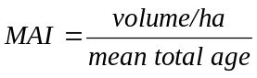

3.15 Mean bark thickness by species
Bark thickness (BT) at boring height is recorded for all site trees (prior to 2008) measured for age (top height and random trees). In 2008, the standards were changed to only measure bark for trees with an imcomplete ring count. The VRI compiler uses this data to calculate the bark thickness percentage (%BT) of the outside bark (ob) diameter at the boring height. An average is then computed for each species in the sample. Random height trees are totaled separately. Note: Bark thickness is in millimetres.
Equations:
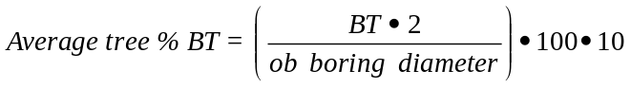
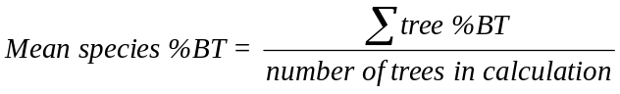

3.16 Small tree summary
Trees less than 4 cm in dbh are sampled on the fixed area subplot. Dot tallies record the number of small trees by species and height class. This field is weighted by plot size (i.e., if it is a 1/2 plot, then the result is multiplied by 2).
There are three height classes:
- 0.1 m to 0.3 m
- 0.3 m to 1.3 m
- Greater than 1.3 m (less than 2 cm dbh)
The equation to calculate the number of small trees per hectare by species and height class is:
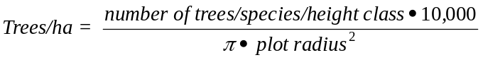

3.17 Stump volumes
A stump is recorded as such if it is less than 1.3 m in height. Stumps are recorded only on the fixed area subplot.
The volume equation for a cylinder is used to calculate the volume of a stump. Data inputs are the inside-bark diameter (dib) and the length of the stump. Stump volume/ha is the sum of stump volumes on the plot divided by the plot area (ha).
Equations:
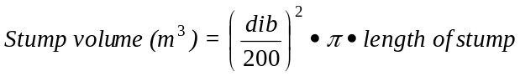
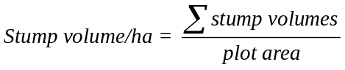

4. Coarse Woody Debris (CWD)
Coarse woody debris (CWD) comprises all types of woody material found on the ground and in various stages of deterioration, such as fallen trees, broken tree tops, large branches, and overturned stumps with no roots attached. It is defined as downed or suspended (not self-supported) woody material greater than 7.5 cm in diameter. It is measured in the field using the line intersect sampling method.
Two methods are used to calculate volumes of CWD depending on whether the distribution of the debris is scattered or in accumulated in piles.

4.1 Scattered CWD
Volume/ha is calculated for each of five decay classes.
Equation: 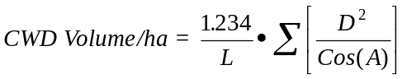
Number of pieces / ha is also calculated when the optional data – length of piece is present.
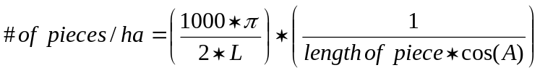
where: L = length of total transect (horizontal distant in meters combined for RS and RT (field card types))
D = diameter of each piece of CWD (cm)
A = tilt angle from horizontal for each piece (degrees)

4.2 Accumulated CWD
Volume/ha is calculated for each accumulation along the transect line by decay class. Volumes are then summed to get the total volume/ha. Note: Height and width are captured in the field in centimetres, but stored in ORACLE database in metres.
Equation: 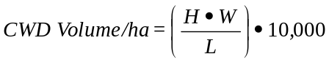
where: H = height of pile (m)
W = width of pile (m)
L = transect length (horizontal distance in metres)

4.3 Totals and classes
The equation for total CWD is:
An optional field in the VRI data compilation process is piece length. Introduced in 1997, this class length variable is used with decay class to provide subset totals. Length class is in multiples of 6 m, as seen below.
Length (m) | Length Class
0.1 to 6.0 | 1
6.1 to 12.0 | 2
12.1 to 18.0 | 3

Diameter classes, introduced in 1998, are also used:
Diameter (cm) | Diameter Class
7.6 - 12.4 | 1
12.5 - 17.4 | 2
17.5 - 25.0 | 3
25.1 - 50.0 | 4
50.1 - 75.0 | 5
75.1 - 100.0 | 6
100.1 - 125.0 | 7
125.1 - 150.0 | 8
150.1 and greater | 9

5. Ecology & Range Derivations
Ecology and range information collected during ground sampling includes detailed descriptions of all types of vegetation consumed by livestock and wildlife. As not all ecology and range data can be measured directly, some compilation is necessary to produce the attributes required for the VRI. The purpose of this data is to estimate the production of forage (i.e., grasses, forbes, and shrubs) and its utilization by animals. These attributes are also summarized to show quality and quantity of vegetation cover.
In addition to the summaries described below, the ecological data is destined to be stored as an MS Access database format called VENUS, which is the approved standard for sharing data with the other brances of Ministry of Sustainable Resource Management (formerly Ministry of Environment, Lands and Parks).

5.1 Forage compilation

Total herbaceous production
The steps to calculate the total herbaceous production and the sample average utilization class are:
- Calculate the sample average for forbs (kg/ha):
Equation: 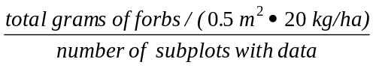
- Calculate the sample average for graminoids (kg/ha):
Equation: 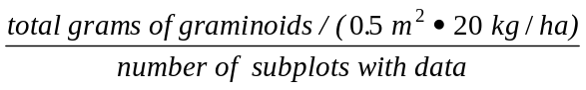
- Calculate the total average herbaceous production :
Equation: graminoids kg/ha sample average + forbes kg/ha sample average
- Calculate the sample average utilization class:
Equation: 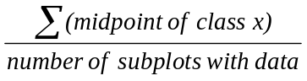
Where: x is the class as defined in the manual
For example:
(mid point of class 1 + mid point of class 1 + midpoint of class 4)/3
Note: For 1995, it should be divided by the number of subplots for which there are data to a maximum of 4. For 1996 and beyond there is only 1 bag for collection, but the data should still be divided by 4. For column 98 of card type RS, blank = zero in this case and only this case.

Percent shrub cover
The steps for determining the percent shrub cover are:
- Calculate the sample average percent cover by species for layer B1 and layer B2.
Equation: 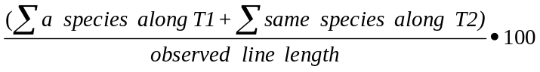
Note: there may be 2 or more records per sample and B1 may not have any values.
- Calculate the sample average percent cover in metres for all shrubs in each layer.
Equation: 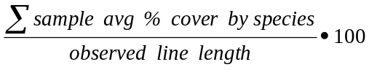
- Calculate the sum of layer B1 and B2 by species.
Procedure:
- Sum the sample average percent cover values obtained for individual species for layers B1 and B2.
- Calculate the sample total percent cover of all shrubs combined for both layers.
Procedure:
- Sum the values from Step 3.
- Sum the sample average for B1 and the sample average for B2.
- Calculate the average phenological class for all shrubs and deciduous trees in both layers.
Procedure:
- Sum of all shrubs in T1 for layer B1 and layer B2 plus sum of all shrubs in T2 for layer B1 and layer B2.
- Calculate the number of non-blank observations (i.e., if there is an observation, 0 or a value, then increment a counter).
Equation: 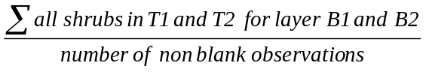
- Calculate the average phonological class for conifer trees in both layers (see Step 5).

Where T1 = Transect 1,
T2 = Transect 2.

5.2 Range summary data from the vegetation plot
The range summarized files include information which is copied from the Min. of Forests, Research Branch. BC Plant Species and selected attributes, current version): This information includes:
- Latin and common names,
- if the plant is poisonous, and to what lifeforms, and
- if it is a weed species.

5.2 Ecological Summary data:

The ocular estimate data from Cards ET and EH undergo a very basic summarization as well as relevenat data is extracted from the Min. of Forests species list, as described above.

Glossary
B1 Layer | Shrubs 2-10 m in height (no trees).
B2 Layer | Shrubs and trees less than 2 m in height.
Bark Thickness | The average of at least two readings of bark thickness measured with a bark gauge or calipers.
Basal Area | The cross-sectional area of a tree at 4.5 feet above ground level.
Basal Area Factor (BAF) | Factor used to convert sample information to basal area per unit area.
Bole | Stem.
Boring Height | Height at which the radial core of rings is extracted to determine age.
Breast Height | 1.3 metres above the point of germination.
Breast Height Age | Age measured from a core taken at breast height.
Call Grade | The classification of timber, lumber or logs according to quality or end use.
Cluster | Sample plot.
Coarse Woody Debris (CWD) | Downed or suspended (not self-supported) woody material greater than 7.5 cm in diameter.
Damage Agents | A set of codes completed on card TL and looks at mortality conditions for all agents, bark beetles, defoliators, needle rust and blights, terminal weevils, stem rusts, root rots, Dwarf mistletoes, stem swelling for coastal mistletoe, mammals birds, etc, and defoliators (i.e., codes collected about the tree to indicate what if anything has damaged it).
Diameter at Breast Height (dbh) | The diameter measured at 1.3 metres above the point of germination.
Diameter Inside Bark (dib) | The diameter of a tree or log excluding bark thickness.
Forbes | Any broad-leafed herbaceous plants except Gramineae (or Poaceae), Cyperaceae and Juncaceae families; and for forage measurement purposes, includes ferns and fern allies, club mosses and horsetails.
Forest Inventory Zone (FIZ) | Inventory unit of similar forest types.
Graminoids | Grass or grass-like plants (sedges and rushes) such as Poa, Carex, and Juncus species.
Ground Sampling | The measurement of tree and other vegetation attributes from a sample of the polygons to provide overall totals and averages for timber and non-timber vegetation resources in an inventory unit, and to provide the basis for statistical adjustment of the photo interpreted estimates.
Gross Total Volume | The volume of the main stem of a tree including stump and top, or the volume of the stand including all trees.
Increment Core | The part of the cross section of a tree extracted by an increment borer. Used to determine tree age and growth pattern.
Key Range Plants | Forage species that must, because of their high degree of use, be considered in the management program.
Lorey Height | Average stand height weighted by tree basal area.
Mean Annual Increment (MAI) | The average annual increase in volume of individual trees or stands up to a specified point in time.
Net Volume | Volume of the main stem excluding stump and top as well as the defective and decayed wood of trees or stands.
Per Hectare Factor (PHF) | A number used to convert sample plot information to per hectare information.
Potential Natural Community | The biotic community that would become established if all succession sequences were completed without interference’s by man under the present environmental conditions.
Quadratic Mean Diameter (QMD) | The dbh of the tree of average basal area within a group.
Relascope | An angle gauge for measuring small horizontal angles, with automatic compensation for inclined sight lines.
Sample Plot | A carefully measured area laid out for measurement.
Shrub Cover (foliar coverage) | The percentage of ground covered by vertical projection of the aerial portion of plants. Small openings in the canopy and intraspecific overlap are excluded. Foliar cover is always less than canopy cover, either may exceed 100%.
Site Height | The average height of the selected site trees in the sample. Heights are collected for site trees and one randomly selected tree.
Site Index | A measure of site quality expressed as the site height in metres at a breast height age of 50 years.
Site Trees | First and second leading species trees. Identified as ‘L’ (leading species in the sample) and ‘S’ (second species in the sample).
Slash | The residue left on the ground after felling, including unused logs, uprooted stumps, broken tops, etc.
Sampling | The selection of sample units from a population and the measurement and recording of information on these units to obtain estimates of population characteristics.
Stems per Hectare (SPH) | The total estimated number of trees per hectare.
Strata | Groups of forest types with the same or similar species composition, age and height class.
Stump | Less than 1.3 m in height.
Taper | The decrease in stem diameter with increasing height up the stem.
Timber Value | Calculated for a species and log grade and expressed as dollars per hectare.
Total Age | Derived value.
Transect Line | A cross-section of an area used as a sample unit for recording mapping or studying the vegetation and its use. May be a series of plots, a belt or strip, or merely a line, depending on the purpose.
Tree Volume | The volume or weight of the commercially marketable portion of a tree.
Utilization Standards | The utilization limits (stump height and top diameter inside bark) which define commercially saleable trees, thus the trees to be harvested.
VBAR | The ratio of volume/basal area calculated for individual trees or stands.
Weed Species | Plants that interfere with management objectives for a given area of land at a particular time. BC Noxious weeds are defined and listed in the Weed Control Act and are designated by the Weed Control Regulation. Noxious weeds are typically difficult to control, have significant impacts on forage for livestock and wildlife, and threaten the biodiversity of native plant communities and forest regeneration.

